AI Use Declaration Form
Course: Introduction to Artificial Intelligence
Lab Title - Lab 4: LLMs and Prompt Engineering for Decision Support
Student Name: ___Raicha Adamou Ibrahim________________________________________________
Student ID: __________30932027____________________________________________
GitHub Repository Link: _____https://github.com/raicha2027/lab-4-llm-decision-support.git ________________________________
Date Submitted: ____________8/15/2026______________________________________

1. AI Use Summary
Question | Student Response
Did you use any AI tool for this lab? | Yes
Estimated percentage of the work influenced by AI | 15 %
Did you attach evidence of AI use where applicable? | yes

2. Details of AI Use
Complete the table below for each AI tool used. Add more rows where necessary.
Name of AI Tool Used | Purpose for Using the Tool | Prompt or Instruction Given to the Tool | Part(s) of the Work Influenced by the Tool | How I Verified, Edited, or Improved the AI Output
ChatGPT | Got some error in my code and had to copy the line error to the ai so it will guide me, and also didn’t know how to do the Groq so I had to asked AI for assistance | 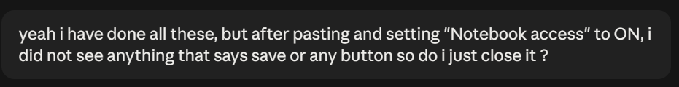 | 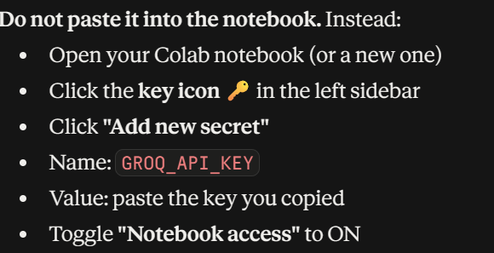

3. Attachment of AI Output Evidence
Where required, attach evidence of AI use. Tick all that apply. Add more rows where necessary.
Evidence Type | Attached? (Yes, No, N/A) | File Name
AI-generated draft
Prompt history | 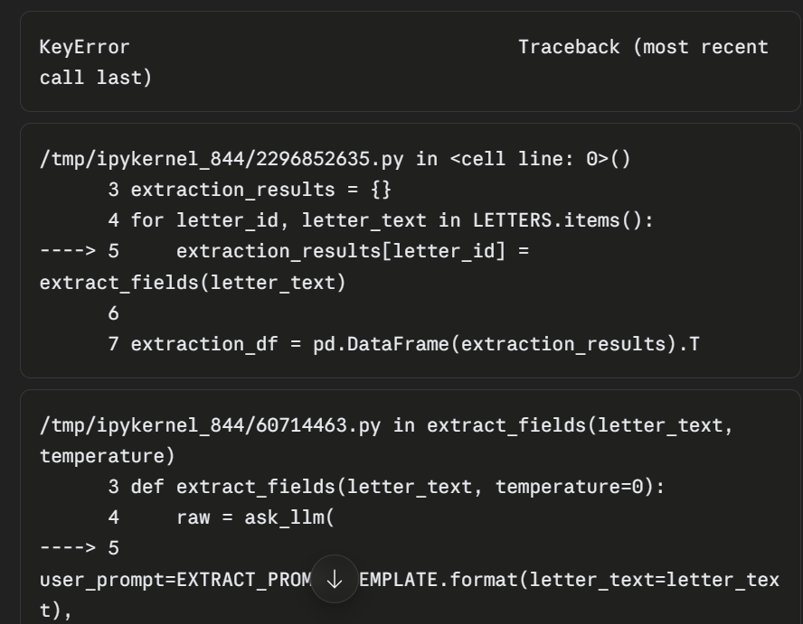
Screenshot of AI interaction
Exported AI conversation | 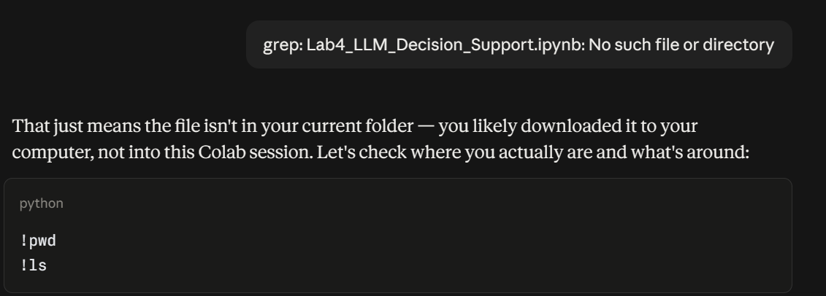
AI-generated code snippet | 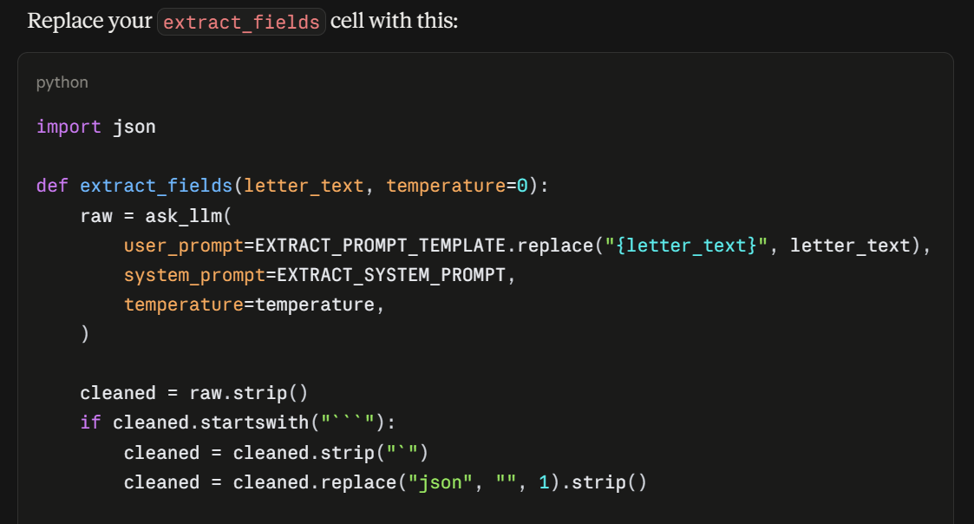
Revised version showing student input | 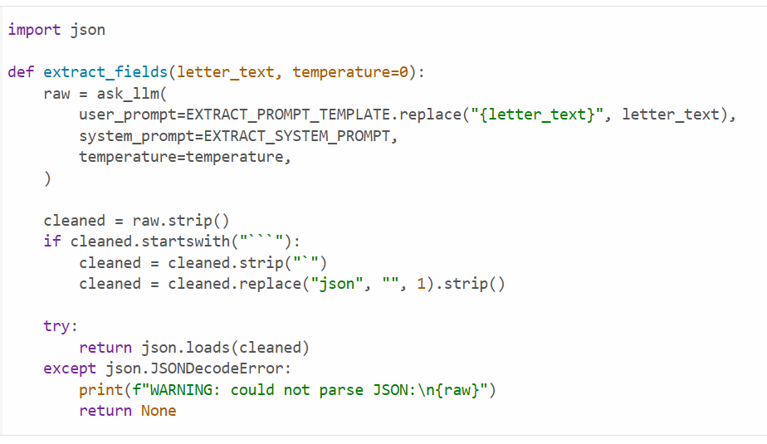

4. Student Declaration
I declare that:
Declaration Statement | Response (Yes/No)
The submitted work is my own work. | yes
Any use of AI tools has been clearly declared in this form. | yes
The prompts, instructions, and AI-generated outputs have been disclosed where applicable. | yes
I reviewed, tested, edited, and improved any AI-generated content before submission. | yes
My AI usage does not exceed 25% of the entire work. | yes
I understand that undeclared or excessive AI use may be treated as academic misconduct. | yes

Student Signature: ____Raicha_______________________________________
Date: _________8/15/2026__________________________________

